


DATABASE APPLICATIONS
(240)

STATE – 2020

Production:

Printout 1: Property Table (60 points)

Printout 2: Enter Work Orders Printscreen (70 points)

Printout 3: Enter Work Orders Form (2 pages) (30 points)

Printout 4: Rent per Square Foot Query (40 points)

Printout 5: Rent per Square Foot Query + criteria (25 points)

Printout 6: City Property with Work Orders Report ______________ (70 points)

TOTAL POINTS (295 points)

Judge/Graders: Please double check and verify all scores and answer keys!

Property of Business Professionals of America.
May be reproduced only for use in the Business Professionals of America
Workplace Skills Assessment Program competition.

General Instructions

You have been hired as a database specialist and will be assisting on various activities throughout Professional Business Associates, located at 5454 Cleveland Avenue, Columbus, Ohio 43231. Professional Business Associates provides accounting, software, programming and other services for clients.

- You will have 90 minutes to complete your work.

- Check that you have all the test pages.

- Your name, initials, and school should not appear on any work you submit. Instead, type your contestant number everywhere XX-XXXX-XXXX appears.

- If you finish before the end of the testing time, notify the administrator of the contest. Time may be a factor in determining a winner when there is a tie score.

- When turning in your completed work, order the printed pages by job number, and place your scoring sheet on top of all your jobs. Turn in all pages printed including incorrect printouts (draw a line through each incorrect printout and place it at the back of the group).

Project: A customer needs assistance in developing a database to better manage their single-family rental homes. The customer is requesting a form to enter work orders as they are received and a customized report.

Create a database named State-XX-XXXX-XXXX, and save it as directed by the administrator.

DATABASE APPLICATIONS
SCORING SHEET
Unless indicated otherwise, student receives all points or none. | Points Possible | Points Earned
Printout 1 – Property Table (60 points maximum)
Imported spreadsheet fields correctly (8 fields at 5 points a field) | 40
Sorted by City (ascending) | 10
Printed using best fit in landscape orientation (all data shows, 1 page) | 10
Misspellings or wrong data entered -1/2 pt per occurrence up to -10 max. Should also be 0 points for imported spreadsheet correctly.
Printout 2 – Enter Work Orders PrintScreen (70 points maximum)
Created a form with the correct fields (5 fields at 5 points a field). | 25
Property ID field is a combo box (signified by the down arrow on the printout) | 10
Repair Category is a list box (look at next printout field should be highlighted black) | 10
Word “completed” has been formatted to stand out. | 5
Two buttons (Add Record and Last Record) have been added. (5 points each) | 10
Form is laid out so it is easy to read and understand. | 10
Printout 3 – Enter Work Orders Form (30 points maximum)
Title is Enter Work Orders xx-xxxx-xxxx. | 5
Correct information was added to the form (4 records) | 10
Imported Work Orders spreadsheet and 3 records are visible in printout. | 15
Printout 4 – Rent per Square Foot Query (40 points maximum)
Title is Rent per Square Foot Query XX-XXXX-XXXX | 5
Correct fields are included in the report (6 fields x 1 points each) | 6
Rent per Square Foot field calculations are correct. (this is all or nothing) | 19
Query sorted descending by rent per square foot field. | 5
Printed in landscape orientation, 1 page, all fields fully visible | 5
Printout 5 – Rent per Square Foot Query with CRITERIA (25 points max)
Correct city is used as the criteria. | 10
All field titles and entries can be completely seen (no hidden or truncated) | 10
Printed in landscape orientation, 1 page. | 5
Printout 6 – City Property Report with Work Orders (70 points max)
Title is City Property Report with Work Orders XX-XXXX-XXXX | 5
Correct fields are included in the report (7 fields x 2 points each) | 14
Report is grouped by City. | 4
Correct work order records are displayed on the report (16 records x 2 points each) | 32
Totals appear and are correct (3 totals at 5 points each)  (Total for Property, Total for City, Total Monthly Rent) | 15
Total Points Earned | 295

Print 1 – Property Table xx-xxxx-xxxx

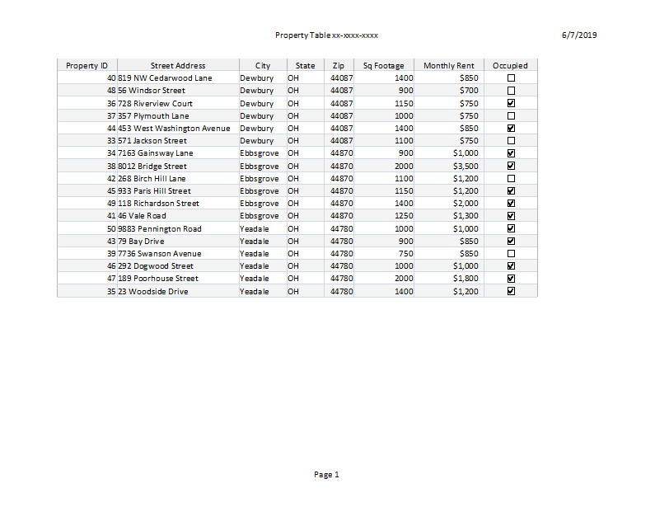

Print 2 – Enter Work Orders Printscreen xx-xxxx-xxxx

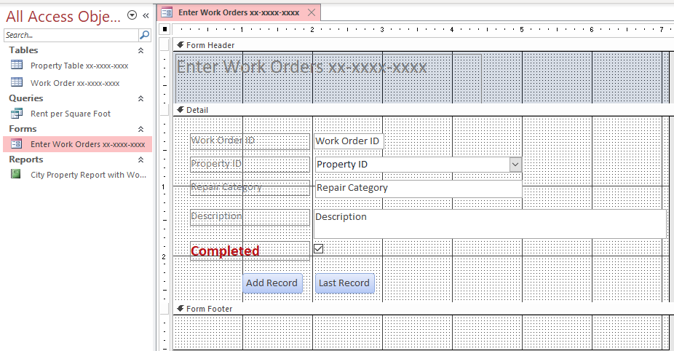

Print 3 – Enter Work Orders Form xx-xxxx-xxxx (Page 1 of 2)

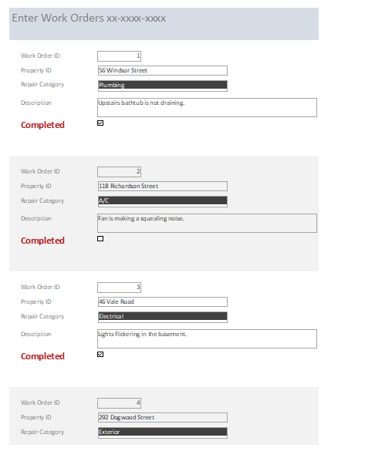

Print 3 – Enter Work Orders Form xx-xxxx-xxxx (Page 2 of 2)

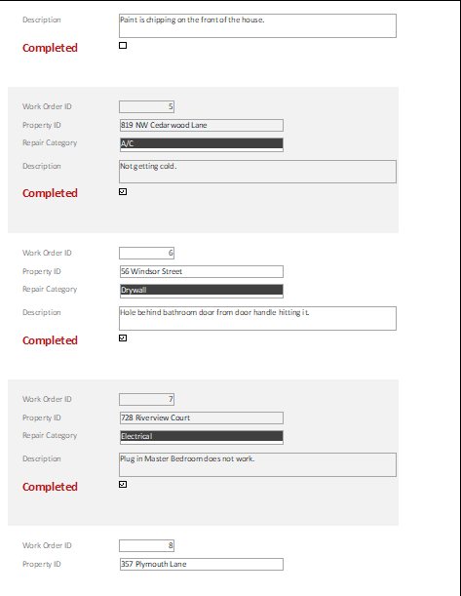

Print 4 – Rent per Square Foot Query xx-xxxx-xxxx

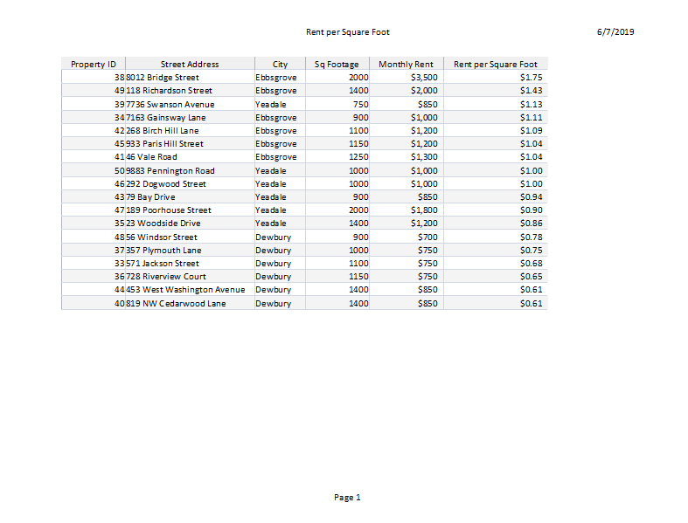

Print 5 – Rent per Square Foot Query + criteria xx-xxxx-xxxx
NOTE: Students should have selected “Dewbury” for the correct city to use as criteria in the query.

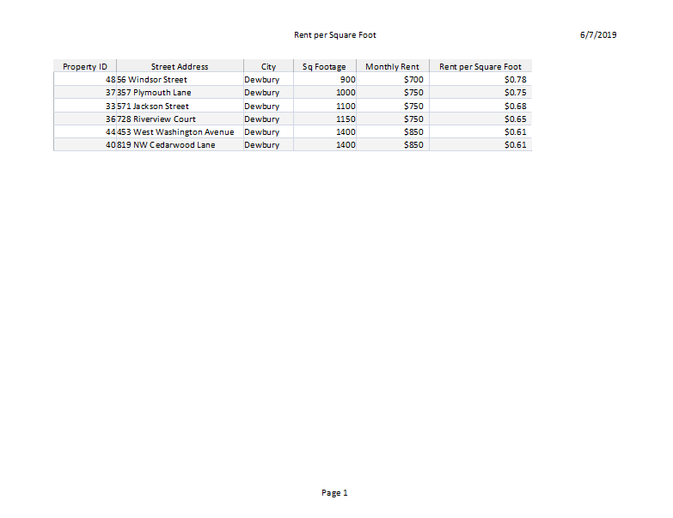

Print 6 – City Property Report with Work Orders xx-xxxx-xxxx (Page 1 of 2)
NOTE: Students should have selected “Dewbury” for the correct city to use as criteria in the query.

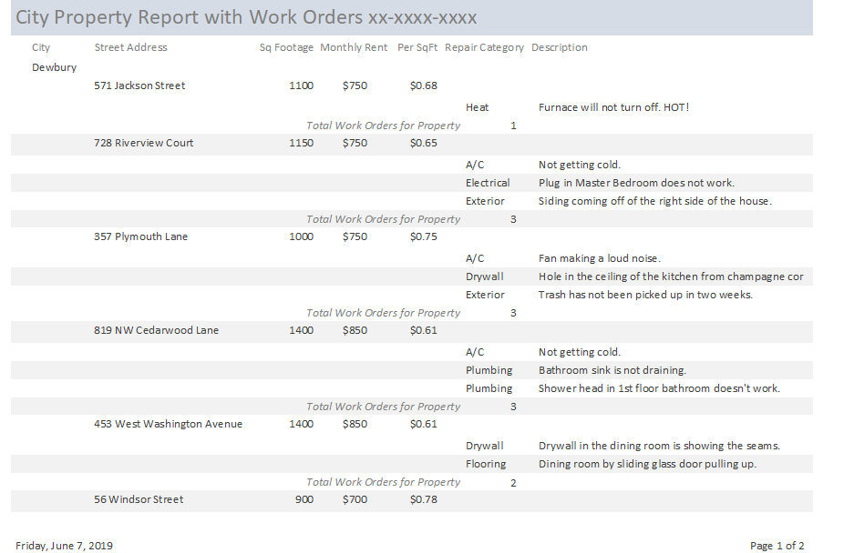

Print 6 – City Property Report with Work Orders xx-xxxx-xxxx (Page 2 of 2)
NOTE: Students should have selected “Dewbury” for the correct city to use as criteria in the query.

